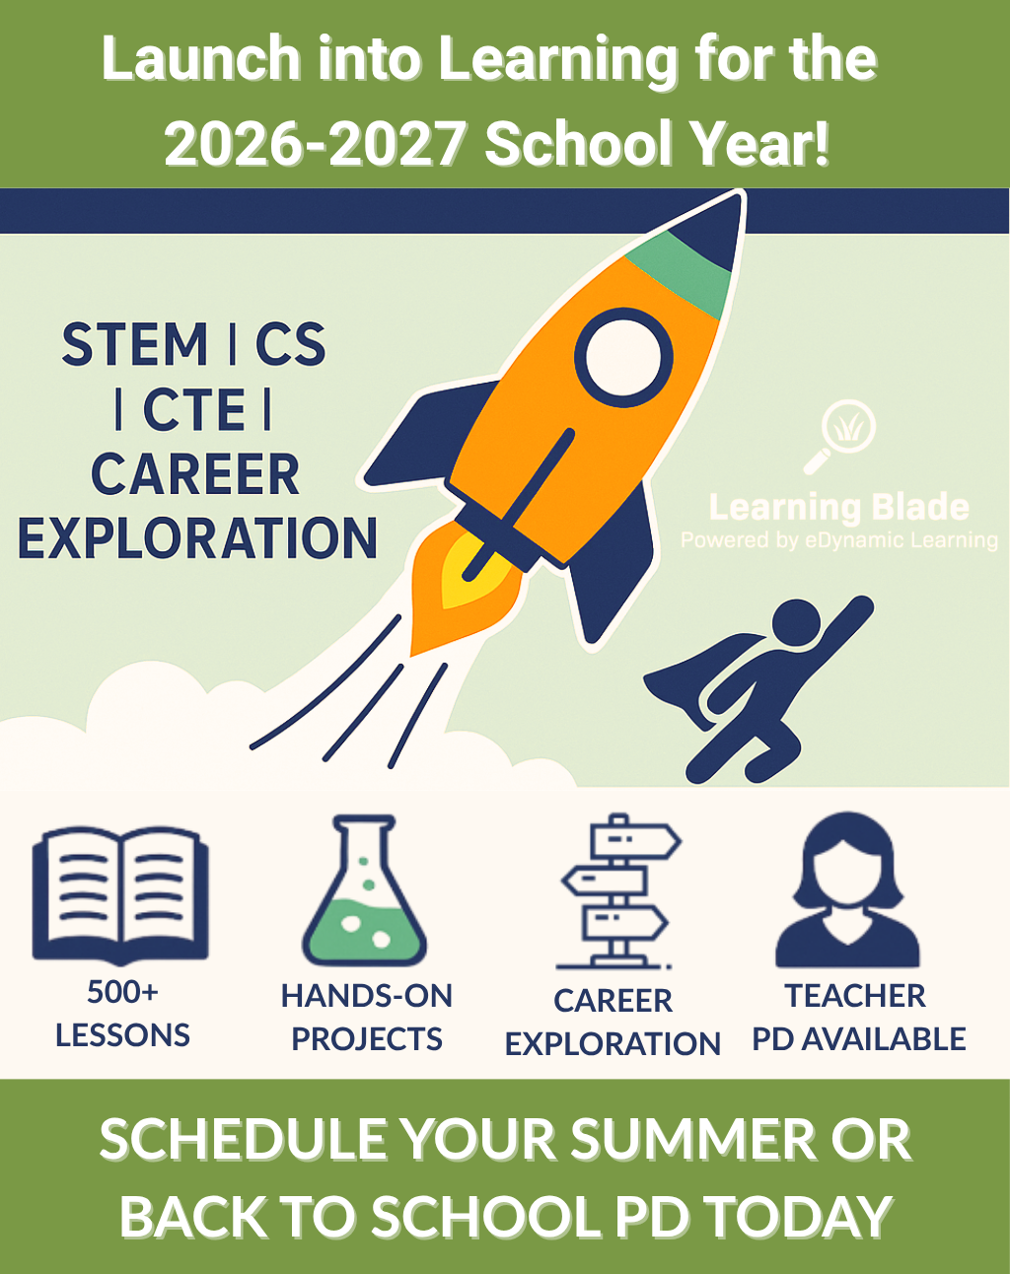
Launch into Learning for the 2026-2027 School Year!
Get a head start on Fall 2026! Now’s the time to prep your STEM, Computer Science, and CTE curriculum with Learning Blade’s 500+ standards-aligned lessons for grades 5–9.
Plan Ahead: Book your FREE summer or back to school PD and explore how Learning Blade brings real-world careers and hands-on learning to life.
Why Learning Blade?
- 500+ interactive STEM, CS, and CTE lessons
- Ready-to-use plans for busy teachers
- Career exploration to motivate students
- Engaging, team-based projects with 3D printing, design & more
Don’t wait! Schedule your summer or back to school PD session today! Sign up for your FREE Learning Blade account here.

Social:

Launch into Learning for the 2026-2027 School Year!
Get a head start on Fall 2026! Now’s the time to prep your STEM, Computer Science, and CTE curriculum with Learning Blade’s 500+ standards-aligned lessons for grades 5–9.
Plan Ahead: Book your FREE summer or back to school PD and explore how Learning Blade brings real-world careers and hands-on learning to life.
Why Learning Blade?
- 500+ interactive STEM, CS, and CTE lessons
- Ready-to-use plans for busy teachers
- Career exploration to motivate students
- Engaging, team-based projects with 3D printing, design & more
Don’t wait! Schedule your summer or back to school PD session today: https://calendly.com/d/3xc-4s3-99n
Sign up for your FREE Learning Blade account: LearningBlade.com/States

