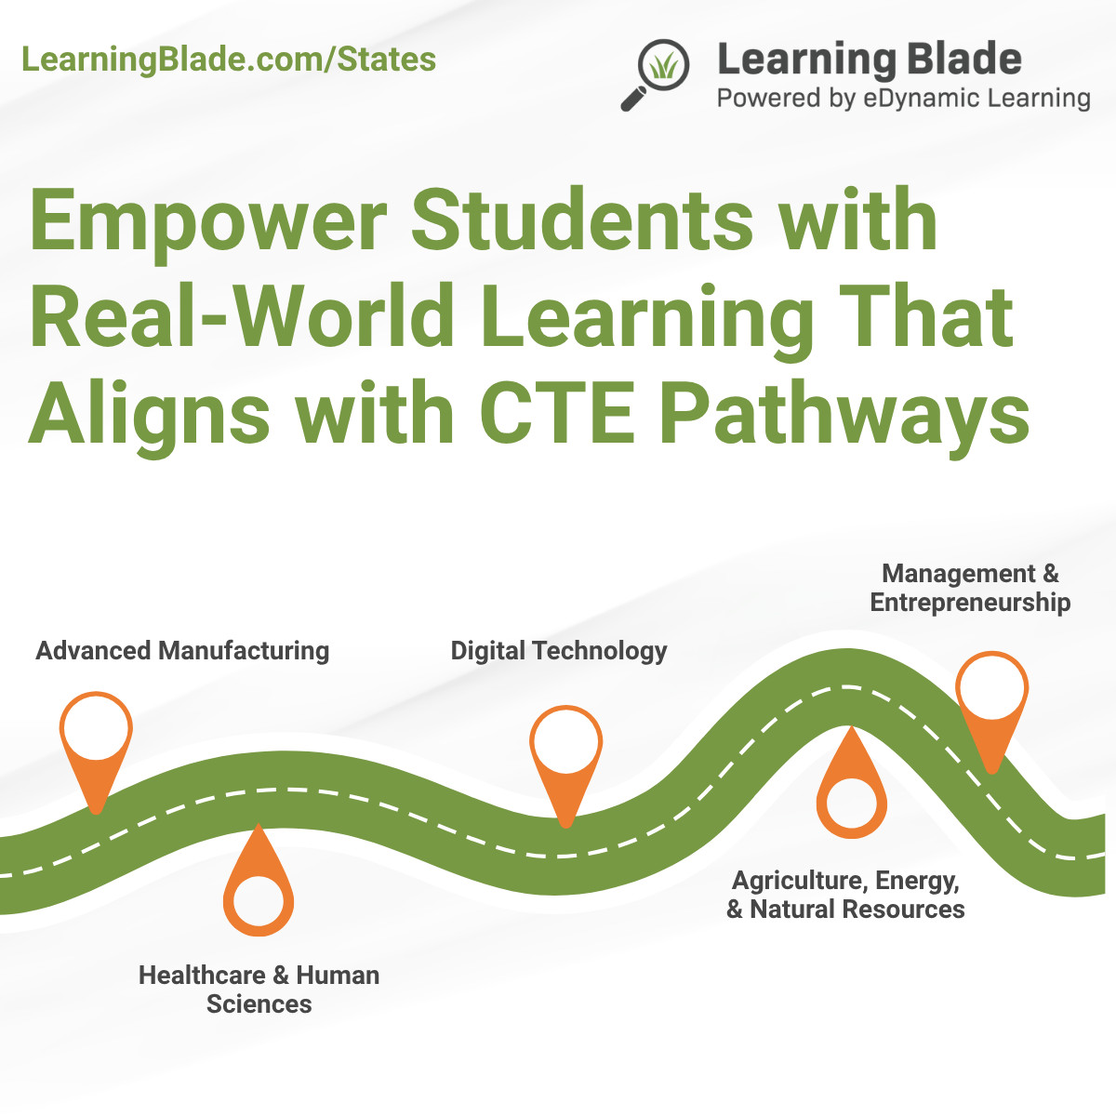
July 26 Learning Blade Corner
Empower students with real-world learning that aligns with CTE pathways!
Learning Blade helps educators bring Career and Technical Education to life through 14 interactive, standards-aligned missions that directly connect to national Career Clusters, including:
- Advanced Manufacturing
  - Build submarines, naval ships, and concept cars using real-world design challenges.
- Healthcare & Human Sciences
  - Explore careers through a heart surgery simulation or dolphin rehabilitation project.
- Digital Technology
  - Defend against a cyberattack or explore the future of innovation with artificial intelligence and coding.
- Agriculture, Energy, & Natural Resources
  - Address modern food production or evaluate clean energy alternatives for real communities.
- Management & Entrepreneurship
  - Empower students to launch their own business venture in a guided simulation.
Whether your focus is full CTE programming or CTE-adjacent STEM and career exploration, Learning Blade delivers an engaging, ready-to-implement resource that supports career awareness, workforce readiness, and cross-disciplinary skills—all while meeting the goals of Perkins V and state-specific CTE frameworks.
Please reach out to schedule your free IL back to school PD’S. We are happy to continue to provide teachers, school and district PD’S for no cost.
Request your fully funded account today: LearningBlade.com/States

Social:
Empower Students with Real-World CTE Learning!
Bring Career and Technical Education to life with Learning Blade, an interactive platform offering 14 standards-aligned missions that connect directly to national Career Clusters.
Featured Pathways Include:
Advanced Manufacturing: Build submarines and concept cars
Healthcare & Human Sciences: Simulate heart surgery or rehab a dolphin
Digital Technology: Defend against a cyberattack or explore the future of innovation with artificial intelligence and coding
Agriculture, Energy, & Natural Resources: Explore clean energy and food systems
Management & Entrepreneurship: Launch a startup in a guided simulation
Whether you’re building full CTE programs or enhancing STEM and career exploration, Learning Blade supports career awareness, workforce readiness, and Perkins V goals.
Get your fully funded account today: LearningBlade.com/States
#CTE #CareerReadiness #STEMEducation #PerkinsV #LearningBlade #FutureReady #EdTech

