Table of Contents
1.0 Overview of Document 2
2.0 I-CARE (Immunization Information System — IIS Modernization) 2
3.0 LIMS (Laboratory Information Management System — LIMS Modernization) 6
4.0 LTC (LTC Licensing and Certification System — LLCS Modernization) 10
5.0 I-NEDSS (Electronic Disease Surveillance System — EDSS Modernization) 14

- Overview of Document
In an effort to maintain the health and safety of every Illinois resident, the IL Department of Public Health (IDPH) is undertaking a large modernization effort. A program critical to this effort is the Public Health Digital Transformation Enablement initiative. The Department of Innovation and Technology (DoIT) is supporting the procurement portion of this program through issuance of this RFP. This section of this document provides the technical background and the target solution architecture for the four critical systems that are encompassed in this RFP. These include Illinois Comprehensive Automated Immunization Registry Exchange (I-CARE), Lab Management Systems (LIMS), Long Term Care (LLCS), and Illinois’ National Electronic Disease Surveillance System (I-NEDSS).

- I-CARE (Immunization Information System — IIS Modernization)
The current state I-CARE, or Illinois Comprehensive Automated Immunization Registry Exchange, is a web-based immunization record-sharing application developed by the Illinois Department of Public Health (IDPH). The application allows public and private healthcare providers to report, monitor and share the immunization records of Illinois residents with other physicians statewide. The State of Illinois is currently engaged in active procurement for these services.
I-CARE is designed to help healthcare provider’s record, track, and report their patients’ immunizations. The registry allows physicians to access patient records for information about immunizations administered outside their practices. Provider participation is voluntary and not all providers within the state choose to participate in the registry. Patient participation is also voluntary. Patients wishing not to have their information included in the registry may opt-out at their provider.
The main features include:
- Calculation of immunization due dates
- Automatic population and printing options for the school physical form and patient immunization history report
- Remind/Recall feature to track and notify patients of due dates
- Vaccine inventory feature to track vaccine usage by lot number
- Ability to record patient contraindications, adverse reactions, or immunities
- Assessment of immunization coverage levels by practice
- Temperature Log feature to track and report vaccine storage by appliance
- Vaccine Information Statement (VIS) module containing up to date VIS forms for printing, distribution, and tracking
Besides keeping track of the immunizations a child has already received, I-CARE forecasts immunization due dates based on the nationally recognized “Recommended Childhood Immunization Schedule.” These recommendations are approved by the Advisory Committee on Immunization Practices, the American Academy of Pediatrics, and the American Academy of Family Physicians.
I-CARE statewide metrics for 2021 and 2022:
 | 2021 |  | 2022 To-Date
 | Total | Avg/Day | Total | Avg/Day
New patients reported | 4,276,892 | 11,717 | 438,271 | 6,261
New shots reported | 28,398,937 | 77,805 | 2,956,374 | 42,234
Vaccine orders | 28,350 | 78 | 4,201 | 60
Vaccine doses ordered | 13,664,637 | 37,437 | 1,075,893 | 15,370
Unique I-CARE logins per day | 828,918 | 2,271 | 171,526 | 2,450
I-CARE page loads | 35,355,314 | 96,865 | 5,538,553 | 79,122

I-CARE interfaces with several applications, including:
- Electronic Health Record (EHR) systems share data with I-CARE using HL7 data exchange.
- I-CARE accepts immunization data in HL7 versions 2.3.1 or 2.5.1.
- HL7 data exchange: a one-way data transfer of unsolicited vaccine record updates the statewide registry. This method accepts batch immunization data using the Department’s Secure File Transfer Protocol (SFTP) system or the I-CARE application.
- A real-time, bidirectional data exchange of vaccine record updates, queries, and responses. This method allows immunization providers using their EHR system to query I-CARE for a patient (not found in their own EHR system) and I-CARE will send the patient immunization information back. It also will allow providers to send updates from their EHR directly to I-CARE for immediate update. This method uses the Hypertext Transfer Protocol Secure (HTTPS) with web services.
Additional systems include:
- Meaningful Use Registration System: Registering Eligible Professionals (EPs) and Eligible Hospitals (EHs) that intend to submit data to IDPH (Registration, iCare, Meaningful use for Provider and Hospital)

Future State Solution Architecture:
IDPH anticipates that a new cloud-hosted IIS Application vendor will be selected and onboarded in early 2023 with a target go live in December 2024. The modernized IIS solution will replace the existing I-CARE solution and will interface with other core state applications via the Rhapsody healthcare integration engine, or the statewide MuleSoft AnyPoint integration hub as illustrated in the Enterprise Architecture Solution Pattern below.
The winning bidder of this RFP will be responsible for providing organizational change management and multi-vendor integration services to the IIS modernization initiative throughout the concurrent life of both vendor contracts.

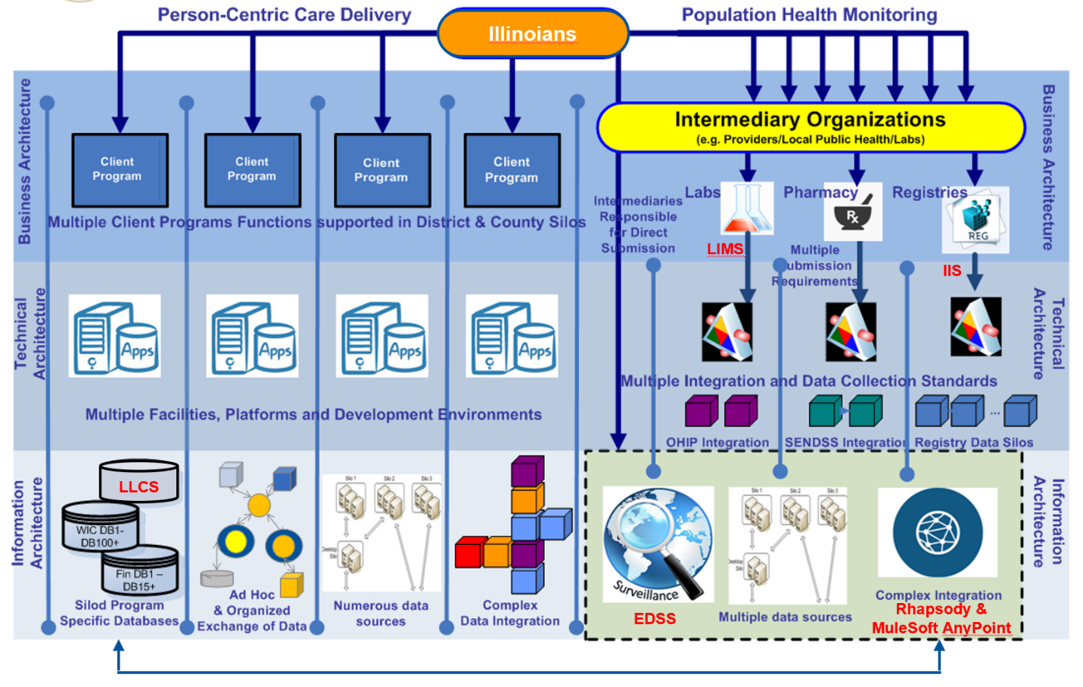
- Future Enterprise Architecture and Solution Pattern

- LIMS (Laboratory Information Management System — LIMS Modernization)
The Laboratory Information Management System (LIMS) current state system is primarily built on the STARLIMS system which supports the laboratory’s operations, integration of laboratory instruments, and data exchange interfaces. It fully "supports its use in regulated environments for testing of Infectious Diseases through lab tests, disease surveillance, analysis, immunization, and education by performing or assuring the ability of laboratory tests.”
IDPH has contracted with Horizon LIMS to modernize the system and is in the design and development phase. The contract is for three phases with the planned phase one go-live scheduled for August 02, 2023. The high-level timeline, major milestones, software configuration, system integrations and data migration plans are included below.
Horizon LIMS Implementation Plan:
Milestone 1: Software Installation: 07/20/2021
Milestone 2: Project Planning: 10/8/2021
Milestone 3: End-to-End Pilot Workflows: 04/15/2022
Milestone 4: Pilot Workflow: 04/15/2022
Milestone 5: Test Code configuration: 10/12/2022
Milestone 6: Instrument Interfacing: 11/02/2022
Milestone 7: Custom Reports: 12/16/2022
Milestone 8: Interfaces: 08/07/2023
Milestone 9: Training: 08/10/2023
Milestone 10: Testing: 09/14/2023
Project Close Out: 10/17/2023
Horizon Software Configuration:
The software has been installed into the pre-production and test environments in HORIZON’s Cloud.
The HORIZON v13.2 software was installed in both environments on October 13th, 2021. This installation was of the HORIZON software, as well as an Oracle Database, and was performed on the following servers:
- w19idphprod.chemwarems.local — This server is used for the pre-prod HORIZON instance of the application and has the HORIZON website installed on it. This server also contains the APIs (Application Programming Interfaces) for HORIZON, LabOnline, and ReportServer.
- w19idphtest.chemwarems.local — This server is used for the test HORIZON instance of the application and has the HORIZON website installed on it. This server also contains the APIs for HORIZON, LabOnline, and Field.
- cwoda03p-scan.chemwarems.local– This server is used for the Oracle Database. It contains schemas for pre-prod and test
- idph.chemwarems.com — This server will be used for the LabOnline application and will have the LabOnline website installed on it.
Horizon System Integrations:
IDPH uses several other systems that will need to be integrated with HORIZON. There are approximately 20 scripts that create HL7, flat files, or other types of batch jobs which create files for delivery.
Each interface will be detailed in an RSSC (Request for Services or Software Change) document, to enumerate and refine the specific requirements for that interface.
The desired interfaces are:
- Undefined number of flat file interfaces
- HL7 — number and types undefined
If new interfaces are identified mid-project, or if the requirements of the interfaces above drastically change from the current expectation, then additional time may be needed.
Horizon Data Migration:
The StarLIMS database will be migrated into the HORIZON database as a separate schema. The data will be able to be queried inside the HORIZON UI (User Interface) via an ad hoc query, and reports can be built off the data. The data will not be able to be edited from the UI. A Final Report template for the StarLIMS data will be created, so that samples can be re-reported if needed from HORIZON. This will ensure that regulations surrounding retention policies can be met. Because this data will be housed outside of the HORIZON schema, any table that needs to be accessed from HORIZON for a report or query, will need to have a database link configured. The HORIZON Cloud team can assist with this task via a support ticket. Once the StarLIMS data is imported, and the specific tables for access are identified, a work ticket will be submitted. Currently, IDPH has allocated 2 TB of storage, with the current size of the StarLIMS database, this import will consume ~13% of the storage allocation. As the HORIZON data grows, either the StarLIMS data will need to be deleted or archived elsewhere. Or additional storage can be purchased from HORIZON Cloud.
Additionally, if the data is clean enough, then the HLS (HORIZON Lab Systems) team can import client/profile data, analyte names, LOINC/SNOMED codes, or inventory into the system if desired. This will be discussed and decided upon. If the data is not clean, and would take significant effort to clean it up, then it is better to just rebuild from scratch. It is not advisable to import junk data into a brand-new system.
Additional systems include:
- Epic LIMS- Lab Management System performs lab testing for Environmental Laboratory Testing for Bacteria, Viruses, and Toxins. (etc.). The mission of the Illinois Department of Public Health (IDPH) Division of Laboratories is to support public health epidemiology programs by providing clinical and environmental laboratory data. The Division of Laboratories serves Illinois’ public health system and environmental protection network with high quality diagnostic and analytical laboratory testing.
- Environmental Lead — Blood Lead Laboratory System: DataEase — Lab Management System performs lab testing for children to identify children with elevated blood lead levels to eliminate the incidence of childhood lead poisoning. Stores patient demographic and result information for pediatric blood lead program.
- Environmental Lead: Maintains licenses for occupations involved in performing lead inspection, abatement, and mitigation in activities in dwellings and childcare facilities. The critical Business process is to ensure the Lead Poisoning Prevention Code requires lead abatement contractors are licensed by the Department.
- Environmental Lead & Copper Analysis: Stores demographic information on location of buildings regarding lead and metals contamination. It maintains records of all environmental lead investigations in compliance with the Lead Poisoning Prevention Code.
- Adult Blood Lead Reporting, Tracks all reported incidences of elevated blood lead levels in Illinois Adults. Tracks all reported incidences of elevated blood lead levels in Illinois Adults.
- Lab Inventory: Tracks inventory of Laboratory equipment
- Newborn Metabolic Screening: Provides analysis of genetic deficiency test results for all Illinois newborns and follow-up for abnormal cases. Early detection, diagnosis and treatment of these conditions can prevent death or disability and enable children to reach their full potential. The Illinois Department of Public Health Newborn Screening Program consists of screening and follow-up for disorders identified including but not limit too through testing a dried blood spot, hearing screening and pulse oximetry screening.
- Electronic HIV (Human Immunodeficiency Virus) Reporting System which is a web-based application hosted by CDC (Centers for Disease Control) as a system specifically tailored for HIV/AIDS Reporting.
- Perinatal HIV Reporting: PHRS will provide a web-based internet-accessible application to hospitals for the collection of data associated with HIV testing of mothers and newborn babies at the time of delivery.
- HIV/AIDS Provide: Used for tracking information on services provided to HIV/AIDS clients in the Direct Services Program.
- HIV/AIDS Surveillance Electronic Document Management: The Illinois Department of Public Health, HIV/AIDS Section administers various programs related to monitoring HIV incidence and prevalence and administering HIV prevention and treatment activities. These activities are coordinated through the HIV Surveillance, HIV Prevention, and the Ryan White Part B Program which includes the Continuation of Health Insurance Coverage (CHIC) Program and the AIDS Drug Assistance (ADAP) Program. The System allows the programs to document, monitor, analyze and report on their related activities in accordance with all applicable State and Federal rules, legislation and statutes and retrieval for all subjects who are registered in the Illinois HIV/AIDS Reporting System (HARS).
- HIV/AIDS ADAP Management System: Used for inventory control and administering program for AIDS Drug Assistance Program. The system distributes HIV/AIDS medication to ADAP clients.
Future State Solution Architecture:
IDPH is in the process of deploying Horizon LIMS to replace its existing lab information system. The modernized LIMS solution will replace the existing StarLIMS solution and will interface with other core state applications via the Rhapsody healthcare integration engine, or the statewide MuleSoft AnyPoint integration hub as illustrated in the Enterprise Architecture Solution Pattern below. The winning bidder of this RFP will be responsible for providing organizational change management and multi-vendor integration services to the LIMS modernization initiative throughout the concurrent life of both vendor contracts.

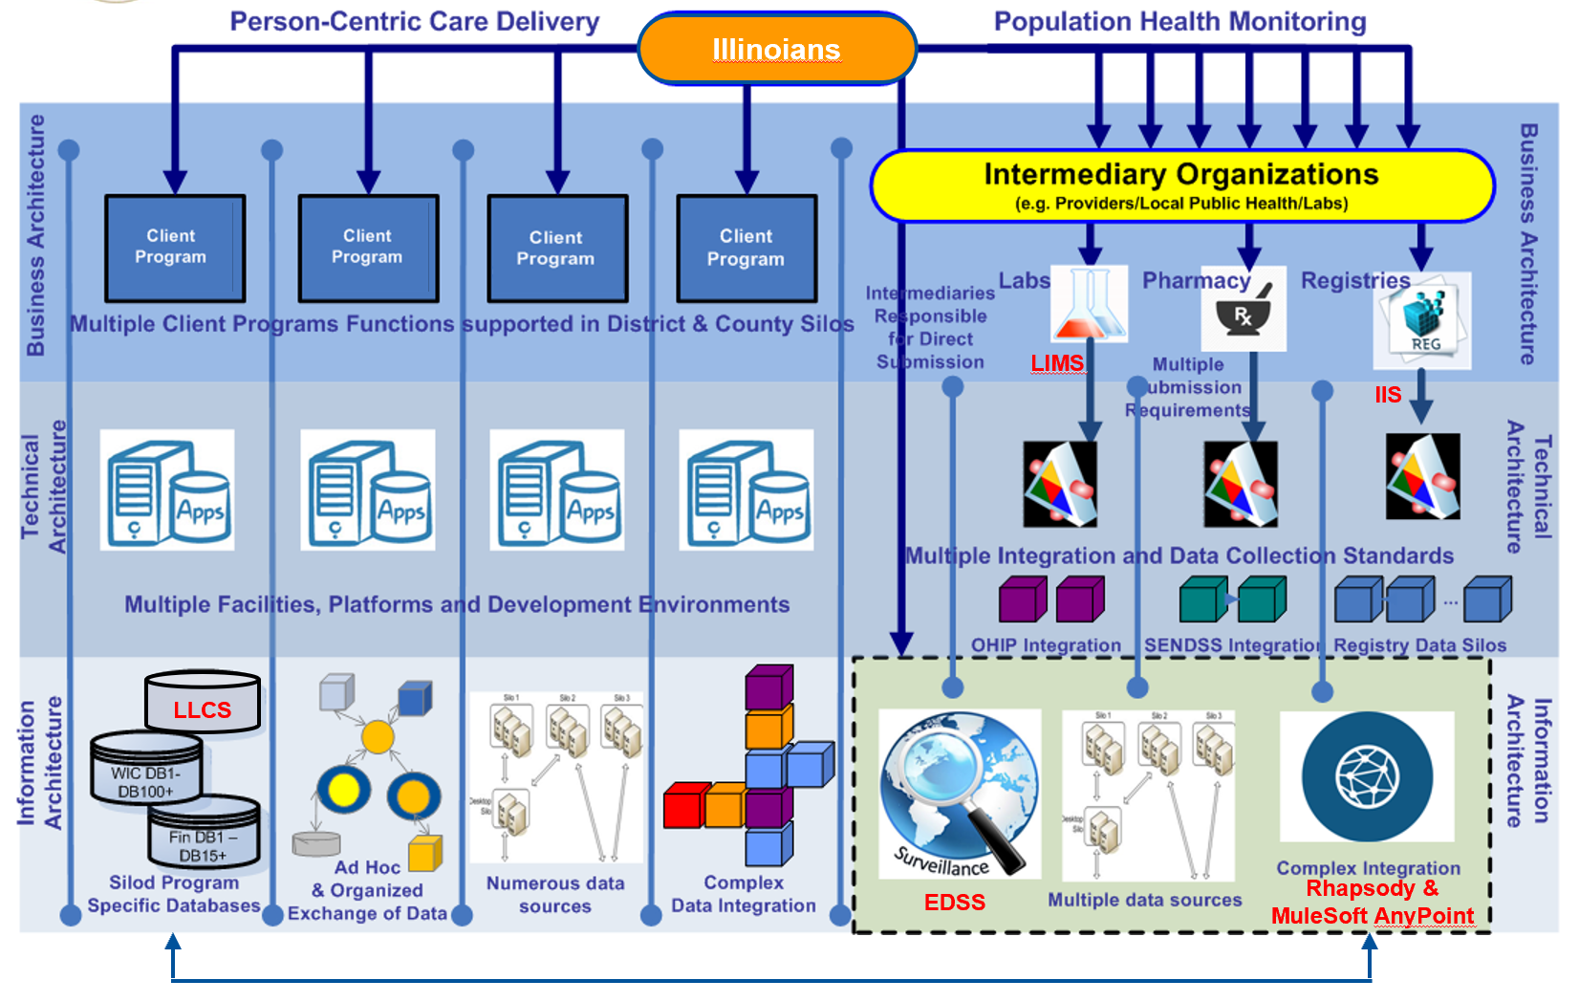
- Future Enterprise Architecture and Solution Pattern

- LTC (LTC Licensing and Certification System — LLCS Modernization)
The Licensing and Certification (L&C) Program is responsible for regulatory oversight of licensed healthcare facilities and healthcare professionals to assess the safety, effectiveness, and quality of healthcare for all Illinois residents.
The LTC current state system is primarily designed and built on the aging Nomad platform, MS Office applications (e.g., Access, Word, Excel, etc.), paper documents, SharePoint, Smartsheet (used by Legal), Lawbase (a database/system used by Legal only) and ASPEN.
A significant portion of the workflow is completed in the federal Aspen system.
The federal system includes:
- Automated Survey Process Environment (ASPEN): A suite of software applications designed to help State Agencies collect and manage healthcare provider data.
  - Electronic Plan of Correction (ePOC): Part of the ASPEN system
- Aspen Central Office (ACO): Part of the federal software system required to be used by all 50 states. It registers Healthcare workers in the Nursing Home industry.
  - CMS-670: In ACO, used to log and track time (hours) spent related to a survey including arrival, departure, off-site and travel times.
- Aspen Complaint and Incident Tracking System (ACTS): Part of the ASPEN system required to be used by all 50 states
- Aspen Survey Explorer — Quality (ASE-Q): Part of the federal software system required to be used by all 50 states. ASE-Q is a client installed on every surveyor’s computer and is used by the surveyor to log the survey investigation.
- Certification and Survey Provider Enhanced Reporting (CASPER): Part of the Quality Improvement and Evaluation System (QIES) which is not part of ASPEN but still part of the federal systems.
- Complaint Original Investigation (COI): The COI includes the original complaint intake and surveyor comments.
- Quality Improvement and Evaluation System (QIES): Not part of ASPEN, but still part of the overall federal software systems.
Additional systems include:
- DocuWare Solution for IDPH Long Term Care Division: DocuWare Tracks inspections process and licensure of Long-Term Care facilities. (PDF generated by Case Workers — Responses to finding
- Legal Case Tracking System: Organizes Dockets and Cases for Legal Services
- Public Health System for Legal Information Management: Organizes Dockets and Cases for Legal Services
- Central Complaint Registry: Track complaints and requests for information or referral for various healthcare facilities. Track complaints for nursing homes, hospitals, ambulatory surgical treatment centers, and home health agencies. Operate hotline, provide requested information, determine complaint severity, investigate more severe calls, monitor call resolutions. The Central Complaint Registry section operates a hotline for telephone calls regarding complaints and requests for information or referral for the following types of facilities within the Department.
- Health Facilities System: To track licensing issuance of hospitals, home health agencies, hospices, ambulatory surgical treatment centers, end stage renal disease facilities and track correspondence and status of these facilities
- Healthcare Worker Registry, Healthcare Worker Registry and Background Checks
- Fee Receipt Entry Sub-System: Front end entry system for the fee system.
- Fee System: Used to validate and record all receipts for the department.
- Identified Offender System: Tracks Identified Offenders in Nursing Homes
- Hospital Report Card & Consumer Healthcare Guide: The HRC website provides the public with comparative cost and quality information across Illinois providers.

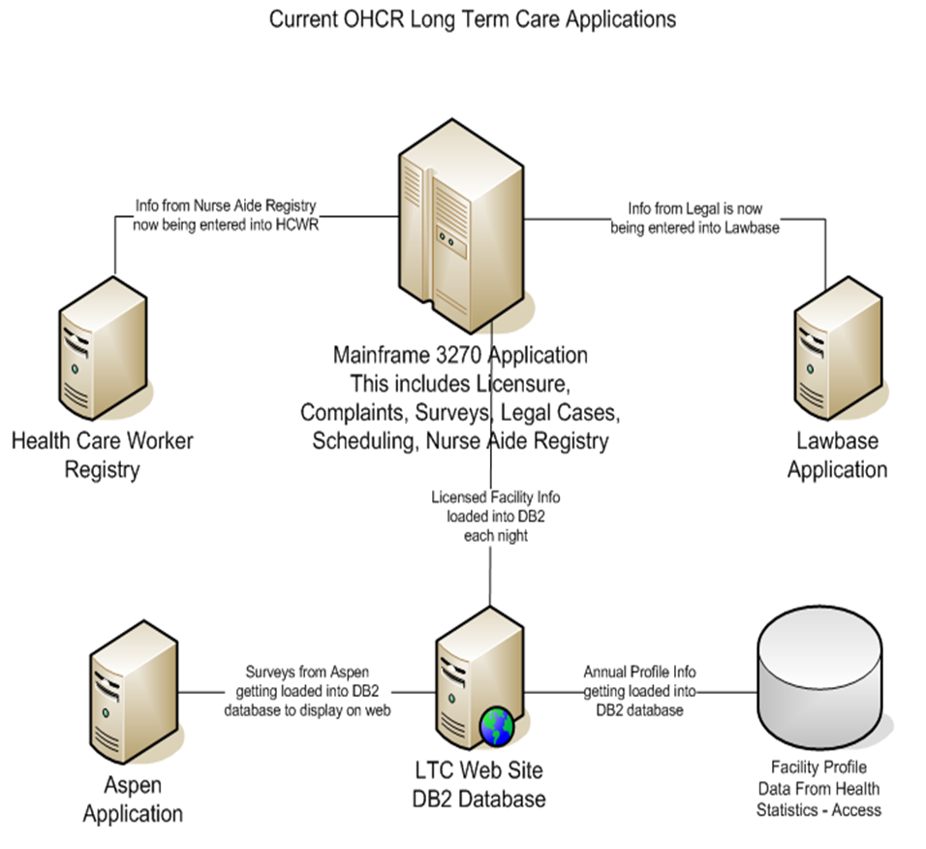
- Current OHCR Long Term Care Applications and Data Flows

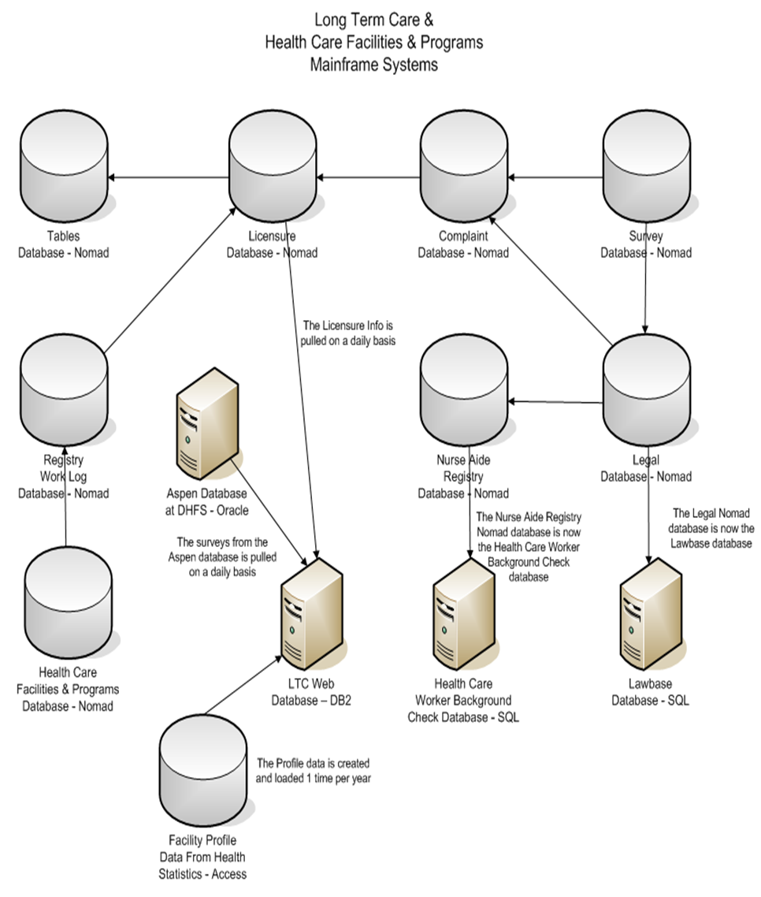
- LTC Mainframe Systems

Future State Solution Architecture:
IDPH anticipates that a new PaaS (Platform as a Service) or SaaS (Software as a Service) solution will be proposed to configure and deploy a new licensing and certification system. The modernized LLCS solution will replace the existing Nomad and surrounding systems and will interface with other core state applications via the statewide MuleSoft AnyPoint integration hub as illustrated in the Enterprise Architecture Solution Pattern below.
The winning bidder for this RFP will be responsible for providing design, development, and implementation services, organizational change management and multi-vendor integration services to the LLCS modernization initiative throughout the concurrent life of both vendor contracts.

- Future Enterprise Architecture and Solution Pattern

- I-NEDSS (Electronic Disease Surveillance System — EDSS Modernization)
The current state Illinois’ National Electronic Disease Surveillance System (I-NEDSS) system is a large-scale, web-based application available to healthcare providers, local health departments and other reporters for input of demographic, medical and exposure information on patients diagnosed with reportable conditions.
I-NEDDS has been used for Illinois disease surveillance since 2008. It is a Java-based application designed and developed by IDPH staff using IBM WebSphere and Db2 database technologies and incorporates separate structures for transactional data and reporting.
The system is operated on behalf of IDPH by DoIT Hosting Services on a cluster of 4 servers and has grown in scale to handle ingestion of lab test results volume of 250,000+ per day.
I-NEDSS Data volumes overview as of July 2021:
- I-NEDSS processes more than 1 million transactions per day.
- There are about 9 million active records on the OLTP database and about 11 million on the OLAP database for live reporting. For historical (achieved) records, there are about 19 million records available on the warehouse side for reporting along with the 11 million active case records.
- More details regarding the main database structures:
- A Db2 OLTP database (transactional database) with:
  - Approximately 130 GB in size and 120 tables
  - 3 million cases and 6.5 million lab/provider reports
- A Db2 OLAP database (reporting database) with
  - Approximately 168.1 GB in size and 189 tables.
  - 3 million cases and 8.8 million lab/provider reports in the reporting database.
- And, additionally, a historical (archived) database with a total of 20 million plus lab/provider reports.

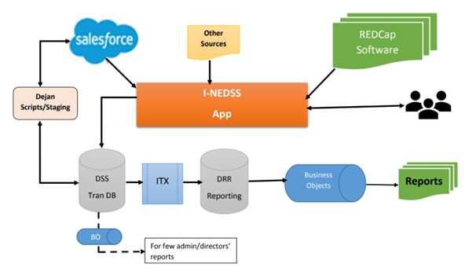
- I-NEDSS Exporting and importing of data

I-NEDSS interfaces with several applications, including:
- Electronic Lab Reports from a variety of sources including the CDC PHIN Messaging System, OSF Healthcare, State Labs and Belleville Hospital using Orion Rhapsody and HL7
- Salesforce for COVID-19Contact Tracing
- REDCap for survey data across a variety of disease conditions and types
  - REDCap is a web-based system, that allows a cost-effective approach to submitting information for public health purposes and speed the Outbreak Management Cycle by quickly sharing outbreak information with public health responders.
- Outbreak Reporting System (ORS)
  - Outbreak Reporting System (ORS) is a web-based application that will facilitate all the local health departments in Illinois with Electronic Data Transfer to IDPH for public health purposes and speed the outbreak management cycle by more quickly and effectively sharing outbreak information with public health responders.
- Illinois Vital Records System (IVRS)
- Immunization Registry (I-CARE which will be replaced by the new IIS)
- Adverse Pregnancy Outcomes Reporting System (APORS).
  - APORS: Registry providing data on congenital anomalies and adverse pregnancy outcomes.

I-NEDSS provides a substantial amount of reporting
- Most I-NEDSS reporting needs are satisfied using SAP Business Objects and data in the OLAP reporting database (DRR) in Figure 1 above.
The table of 91 reports included in the EDSS requirements (Attachment M) provides an indication of the extent of current I-NEDDS reporting.
Future State Solution Architecture:
IDPH anticipates that a new PaaS (Platform as a Service), SaaS (Software as a Service) or remote hosted COTS (Commercial off the shelf) solution may be proposed to configure and deploy a new disease surveillance system. The modernized EDSS solution will replace the existing NEDSS systems and will interface with other core state applications via the Rhapsody healthcare integration engine or the statewide MuleSoft AnyPoint integration hub as illustrated in the Enterprise Architecture Solution Pattern below.
The winning bidder for this RFP will be responsible for providing design, development, and implementation services, organizational change management and multi-vendor integration services to the IIS modernization initiative throughout the concurrent life of both vendor contracts.
- Future Enterprise Architecture and Solution Pattern

